**Manjula Nannuri**

**Day-7 Assignment**

**Assignment 1:** Ensure the script checks if a specific file (e.g., myfile.txt) exists in the current directory. If it exists, print "File exists", otherwise print "File not found".

filename="myfile.txt"

if [ -f "$filename" ]; then

        echo "file exists";

else

        echo "file not found";

fi

OUTPUT:

[root@localhost ~]# bash myfile.txt

file exists

**Assignment 2:** Write a script that reads numbers from the user until they enter '0'. The script should also print whether each number is odd or even.

while true; do

        echo -n " enter a nmber (0 to quit):"

        read n

        if [ "$n" -eq 0 ]; then

                echo "Exiting..."

                break

        fi

        if [ $(expr $n % 2) -eq 0 ]; then

                echo "$n is an even number"

        else

                echo "$n is odd number"

        fi

done

**OUTPUT:**

"oddeven.sh" [New] 16L, 229B written

[root@localhost ~]# chmod u+x oddeven.sh

[root@localhost ~]# bash oddeven.sh

 enter a nmber (0 to quit):4

4 is an even number

 enter a nmber (0 to quit):5

5 is odd number

 enter a nmber (0 to quit):0

Exiting...

**Assignment 3:** Create a function that takes a filename as an argument and prints the number of lines in the file. Call this function from your script with different filenames.

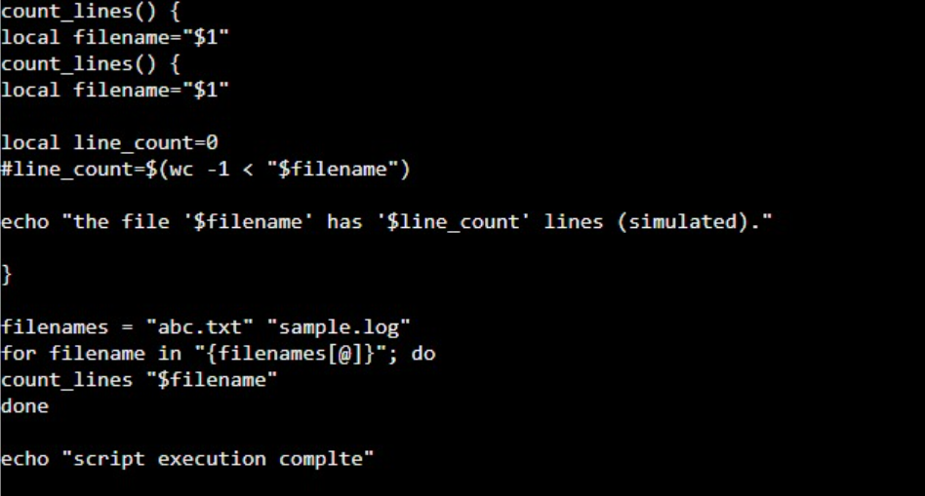

**Assignment 4:** Write a script that creates a directory named TestDir and inside it, creates ten files named File1.txt, File2.txt, ... File10.txt. Each file should contain its filename as its content (e.g., File1.txt contains "File1.txt").

directory="TestDir"

if [ ! -d "$directory" ]; then

        mkdir "$directory"

        echo "Directory '$directory' created."

else

        echo "Directory '$directory' already exists."

fi

for i in {1..10}; do

        filename="File$i.txt"

        filepath="$directory/$filename"

        echo "$filename" > "$filepath"

        echo "created file '$filepath' with content '$filename'."

done

OUTPUT:

"diff_filenames.sh" 15L, 341B written

[root@localhost ~]# bash diff_filenames.sh

Directory 'TestDir' already exists.

created file 'TestDir/File1.txt' with content 'File1.txt'.

created file 'TestDir/File2.txt' with content 'File2.txt'.

created file 'TestDir/File3.txt' with content 'File3.txt'.

created file 'TestDir/File4.txt' with content 'File4.txt'.

created file 'TestDir/File5.txt' with content 'File5.txt'.

created file 'TestDir/File6.txt' with content 'File6.txt'.

created file 'TestDir/File7.txt' with content 'File7.txt'.

created file 'TestDir/File8.txt' with content 'File8.txt'.

created file 'TestDir/File9.txt' with content 'File9.txt'.

created file 'TestDir/File10.txt' with content 'File10.txt'.

**Assignment 5:** Modify the script to handle errors, such as the directory already existing or lacking permissions to create files. Add a debugging mode that prints additional information when enabled.

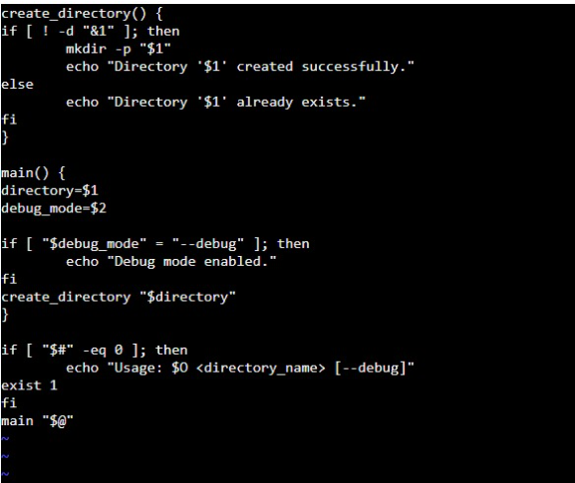

**OUTPUT:**

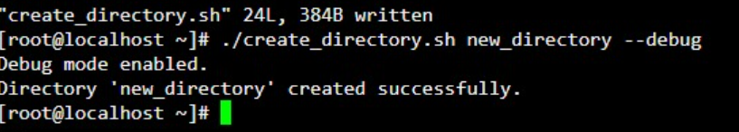

**Assignment 6:** Given a sample log file, write a script using grep to extract all lines containing

"ERROR". Use awk to print the date, time, and error message of each extracted line.Data Processing with sed.

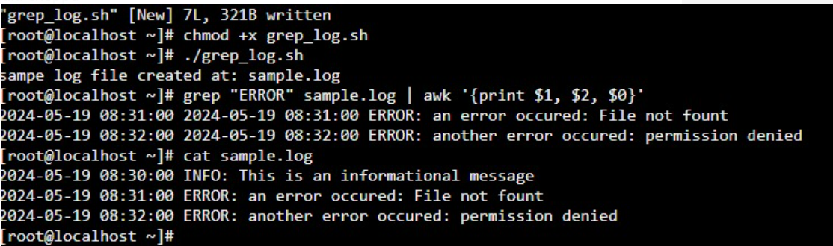

**Assignment 7:** Create a script that takes a text file and replaces all occurrences of "old_text" with "new_text". Use sed to perform this operation and output the result to a new file.

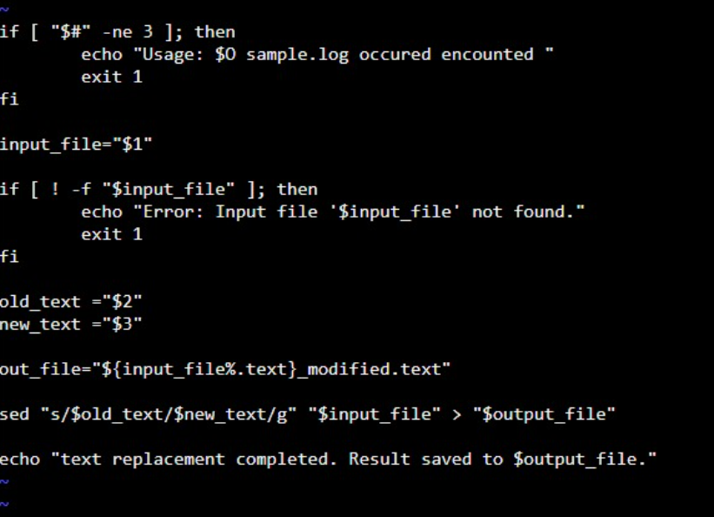

**OUTPUT:**

